https://intjbilling.com

KYC/AML Description for Face-to-Face In-Person Visit Clients
INTJ Billing Pty Ltd conducts in-person consultations with clients who seek specialized advice from myself Clarke Towson, a degree-qualified Computer Scientist. These consultations occur at our premises located at 7 Cullen Court, Spotswood, Victoria, 3015, Australia.
Our clientele consists primarily of Australian residents, most of whom are Australian citizens. They engage our services for professional advice on a wide range of computing topics, including but not limited to Bitcoin, Linux email servers, networking, and general computing advice.
In order to ensure compliance with Know Your Customer (KYC) and Anti-Money Laundering (AML) regulations, INTJ Billing Pty Ltd implements the following procedures for face-to-face, in-person visit clients. It is important to note that while INTJ Billing Pty Ltd does not provide any AUSTRAC designated services, we voluntarily conduct KYC/AML checks for all clients:
- Identification Verification: Clients are required to provide a valid form of government-issued identification, such as a driver's license or passport, to verify their identity. These identity documents are checked using Regula to ensure their identification is authentic.
- Address Verification: Clients must provide proof of their residential address, such as a utility bill or bank statement, to verify their address.
- Payment Verification: Payments for hourly consultations are proposed to be processed using an EFTPOS terminal from Zeller. Clients are required to use a valid debit or credit card to make payments, which would be processed securely through the Zeller payment system.
- Consultation Details: Each consultation is documented, including the date, duration, and nature of the consultation, along with any recommendations or advice provided to the client.
- Compliance Oversight: INTJ Billing Pty Ltd conducts regular audits and reviews of its KYC/AML procedures to ensure compliance with regulatory requirements.
By implementing these procedures, INTJ Billing Pty Ltd aims to mitigate the risk of money laundering, terrorist financing, and other illicit activities, while providing high-quality professional services to our clients.

Yours Sincerely,

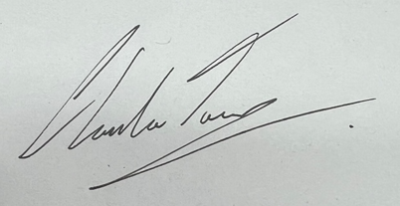
Clarke Towson
Tuesday 16th April 2024

Clarke Towson, BCMS (Bachelor of Computer & Mathematical Science)
CEO
INTJ Billing
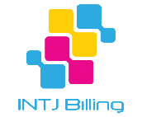
m: +61 432 359 166
a: 7 Cullen Court Spotswood Victoria 3015 AUSTRALIA
w: https://intjbilling.com
e: clarketowson@intjbilling.com

Microsoft Digital Certificate Number:
FF116911EC521DDF424CBCEAF5B5560D1F6E8B8C
Issued to: intjbilling.com
Issued: 23/3/2024

